**Solution for college wifi login**

**For Ubuntu Operating system**

* Go to wifi setting
* Click on college wifi

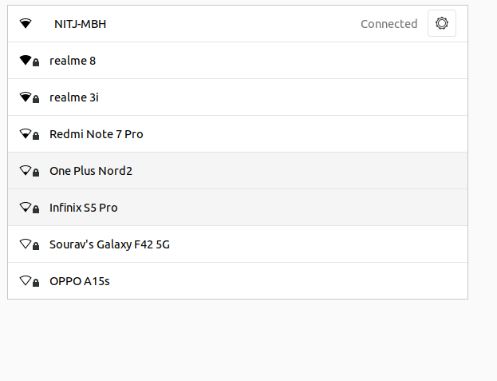

* Click on setting icon
* Click on ipv4 section

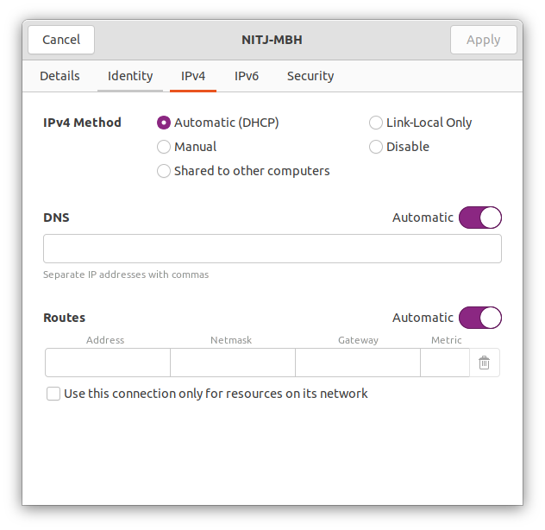

* Click on manual.
* Type these Ip in following blanks… as it is

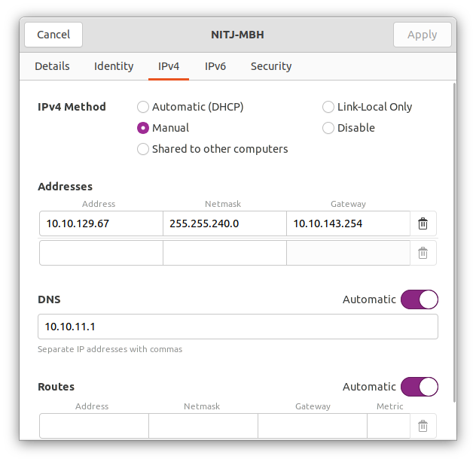

* Put the value of netmask and gateway with the help of the terminal.

Open terminal and type “**route**” and you will get the following interface .

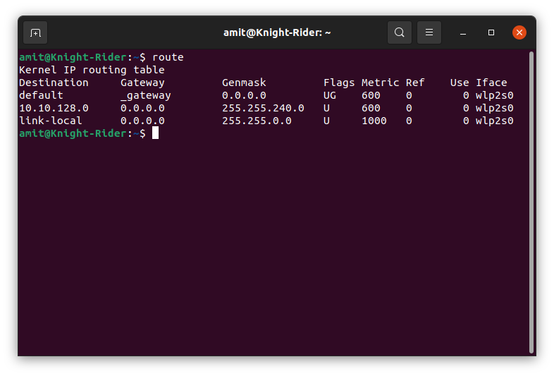

Hope you find this tutorial useful.

See you soon ..

**Thank you**